EGE322 Assignment 3 Jigsaw Learning

Thingsboard Exploration Guide

Introduction

Purpose
This is a guide to setup and connect and ESP32 to ThingsBoard Cloud using MQTT, publish JSON telemetry, and to build a live dashboard. Any reader with access to an ESP32, WiFi, and relevant programming tools should be able to complete the task without extra help

Scope
Included | Not Included
ThingsBoard account, device, access token | ThingSpeak Partner Task
Dashboard Widgets | Adafruit IO (Separate, covered in Lab 8
ESP32 main.py + boot.py | Setup of device control and programming

This example uses internally generated sample data, with no extra sensor data. The guide uses a counter counting from 1 to 100 in steps of 10 every 2 seconds. Optional simulated temperature and humidity values can be sent when running the PC script in “rich” mode (more on that later) if a DHT22 is already wired as in Lab 7, see Appendix A

Architecture

ThingsBoard Account Setup

Create a cloud account
- Open https://thingsboard.cloud and sign up (free tier is enough)
- Log in to tenant dashboard
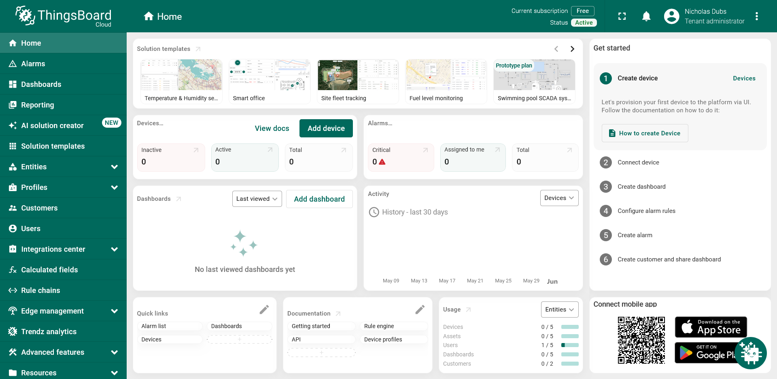
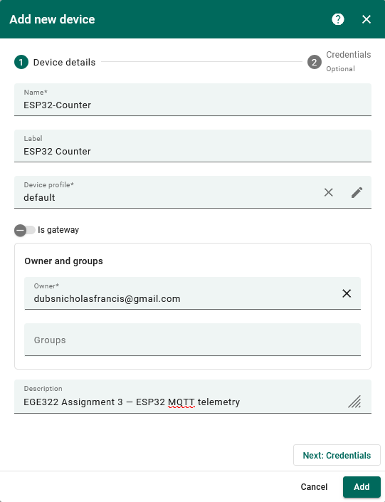
Figure 1: Tenant Dashboard

Create a device
- Click Add a device
- Name: ESP32-Counter
- Label (Opt): ESP32 Counter
- Leave the rest as-is
- Optional description
- Click: Next: Credentials


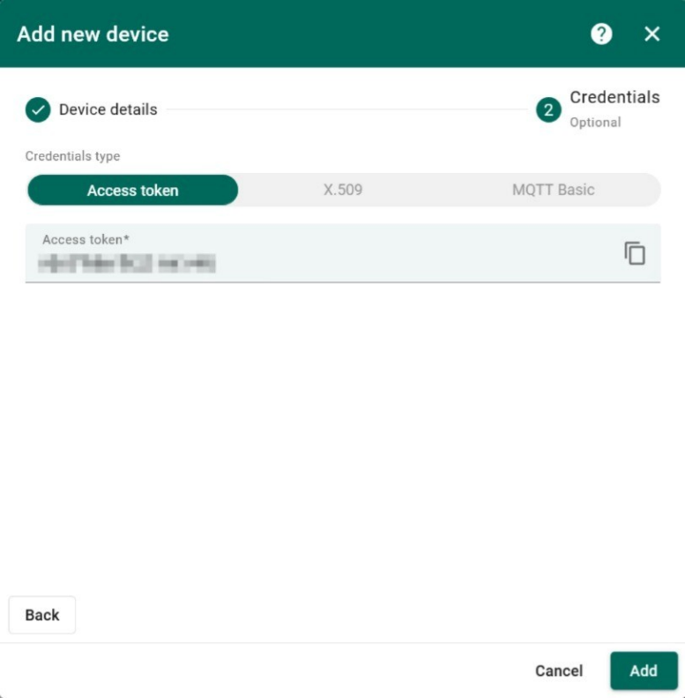
Copy access token
- Open device ESP32-Counter
- Click Copy access token
- Keep for later. Will be used in main.py
- Do NOT share token publicly (treat it like a password)
- Click: Add

MQTT connection settings
Setting | Value
Broker host | Mqtt.thingsboard.clooud
Port | 1883
Client ID | Any unique string (e.g. esp32_thingsboard)
Username | Device access token (from 2.3)
Password | Leave empty
Publish topic | v1/devices/me/telemetry
Payload format | JSON object with double quoted keys*

*Example payload: {"counter": 10, "temperature": 24.5, "humidity": 55.0}
Invalid example: {temperature:24}
Test connection by running the following code in Windows command prompt (Replace with token from 2.3:
curl -v -X POST http://thingsboard.cloud/api/v1/{YOUR_ACCESS_TOKEN}/telemetry --header Content-Type:application/json --data "{counter:10 ,temperature:24.5, humidity:55.0}"

Build the Dashboard

Create a dashboard

Option 1: Generate Dashboard with AI
- Click: Generate Dashboard with AI
- Trust and hope that the dashboard looks semi decent
- Edit dashboard with the right charts and graphs

Option 2: Manual Dashboard Creation
- Go to Dashboards
- Click + Add Dashboard -> Create new Dashboard
- Name: EGE322 Assignment 3
- Description (Opt): EGE322 Assignment 3 Telemetry Dashboard
- Click: Add
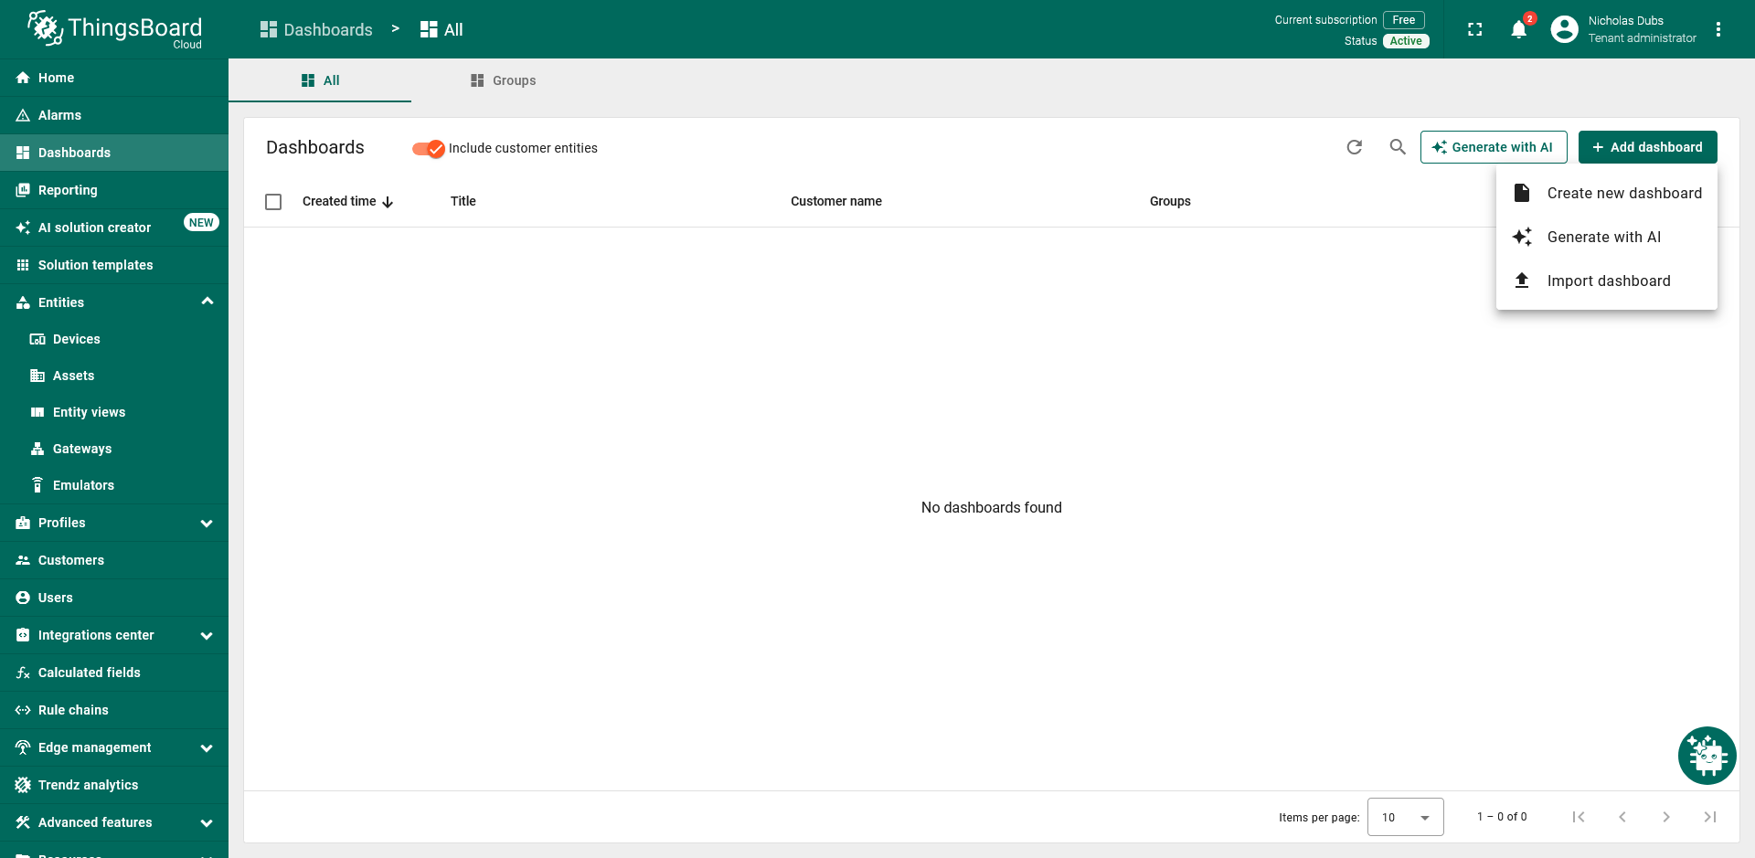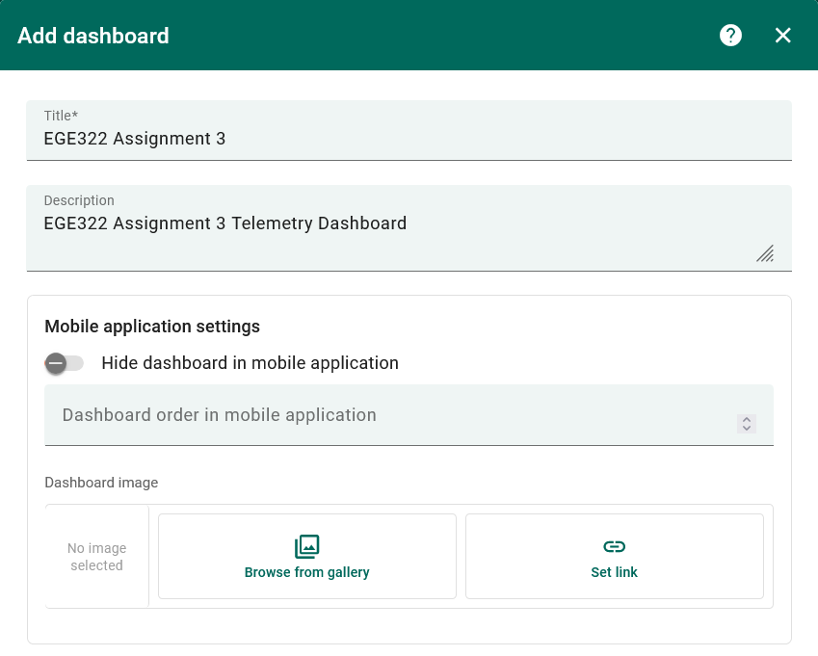

Managing Widgets
- Click + Add Widget
- Click on Charts
- Click on Value and Charts Card
- Time window:
  - Realtime -> Last -> 10 minutes ->
  - Aggregation: None
- Datasource:
  - Device: ESP32-Counter
  - Data key: counter
- Go wild with the rest ig
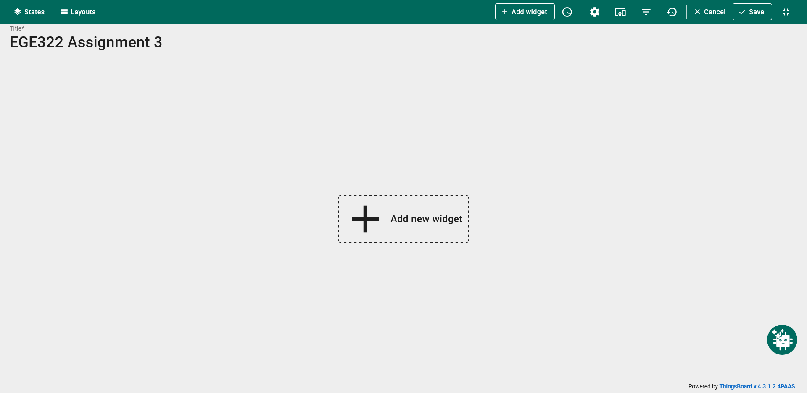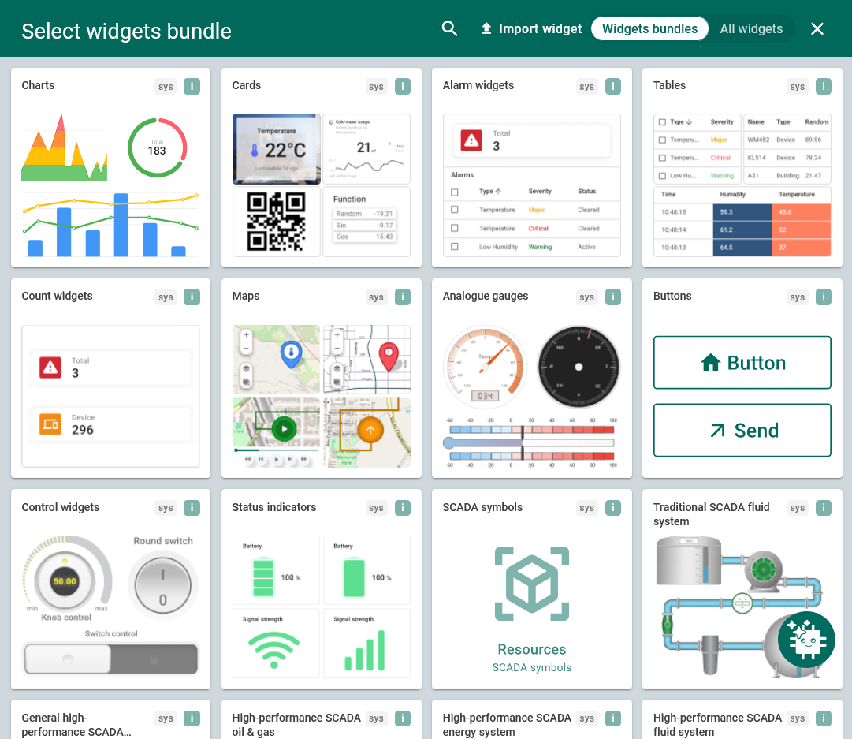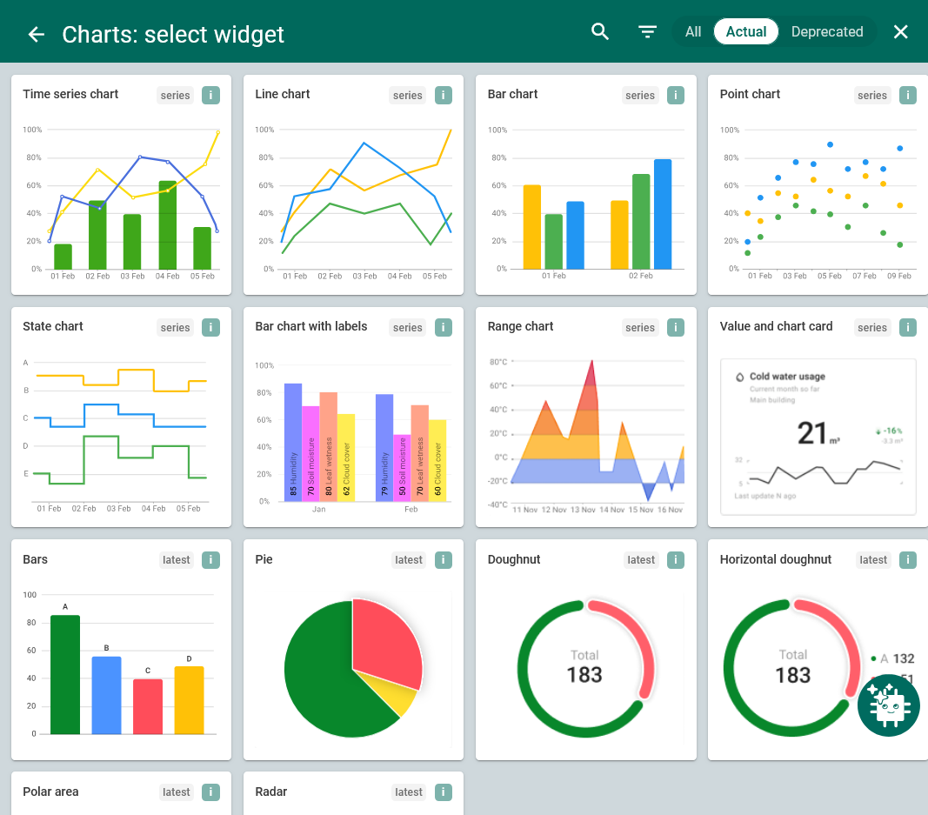
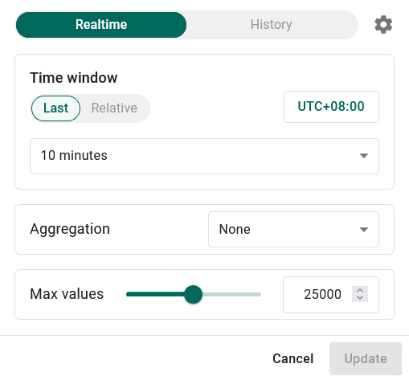

ESP32 setup and MicroPython code

Prerequisites
Item | Notes
Thonny | Connected to ESP32
boot.py | WiFi SSID and password only — do not duplicate WiFi in main.py
Library | umqtt.robust on the board
Reboot | After editing files use Ctrl+D (soft reboot) so boot.py runs before main.py

Install code on the ESP32
- Open Thonny → ESP32 files.
- Confirm boot.py connects WiFi on boot.
- Create/replace main.py with the code in §4.4.
- Replace PASTE_DEVICE_ACCESS_TOKEN_HERE with your token (keep the b"..." bytes form).
- Save to ESP32 → soft reboot Ctrl+D.
[Figure 11 — Thonny showing main.py with token REDACTED]

Run and verify
Expected shell output:
WiFi OK: 192.168.x.x
ThingsBoard MQTT connected
Published: {"counter": 0, "temperature": 24.0, "humidity": 50.0}
On ThingsBoard:
- Entities → Devices → ESP32-Counter → Latest telemetry
- Confirm keys counter, temperature, humidity update.

Full MicroPython listing (assignment — internal sample data)
No external sensor required. Counter matches Basic Task A pattern; temperature and humidity are simulated for chart widgets.

Code notes for troubleshooting:
Line / idea | Why it matters
user=ACCESS_TOKEN | ThingsBoard uses the token as MQTT username
password=b"" | Password must be empty for device token auth
json.dumps(...) | Builds valid JSON; required for multi-key telemetry
qos=1 | At-least-once delivery; matches PC test script
wait_for_wifi() | Avoids MQTT connect before boot.py finishes
Counter 0→100 step 10 | Same pattern as ThingSpeak assignment sample

Results
With main.py running, the dashboard should show:
- Gauge: counter stepping 0, 10, 20, … 100, then resetting.
- Chart: three series updating every ~2 seconds.
(I NEED TO RUN THE CODE THEN TAKE SS OF THE DAHSBOARD)
Figure 14 caption: ThingsBoard dashboard EGE322 Assignment 3 receiving live MQTT telemetry from ESP32 device ESP32-Counter.

Troubleshooting
Problem | Likely cause | Fix
Dashboard widgets empty | Wrong telemetry key | Set widget key to counter exactly
MQTT connect failed | Bad or expired token | Re-copy from device page
WiFi not connected | boot.py wrong / not run | Fix SSID/password; Ctrl+D reboot
OSError -202 after Run (F5) | boot.py skipped | Use Ctrl+D not F5 on main.py only
Chart flat, gauge works | Chart keys mismatch | Add temperature, humidity to JSON
Invalid JSON error | Manual string concat | Use json.dumps()

Limitations
- ThingsBoard free tier — limits on devices, messages, and retention; fine for coursework but not high-frequency production.
- Network — ESP32 needs 2.4 GHz WiFi; guest networks may block MQTT port 1883.
- Security — Access token grants full device access; redact in screenshots and do not commit to public Git.
- Latency — Cloud round-trip typically 1–5 s; not hard real-time control.
- Scope — This guide covers uplink telemetry only, not ThingsBoard rule chains or alarms.
- Platform choice — Adafruit IO (Lab 8) uses per-feed topics; ThingsBoard uses one JSON telemetry topic — different mental model.

What I learned
ThingsBoard treats each ESP32 as a device with an access token used as the MQTT username. Telemetry is one JSON object per publish on v1/devices/me/telemetry, and dashboard widgets bind to keys inside that object. Compared to ThingSpeak MQTT (field1=value strings) and Adafruit IO (username/feeds/name per value), ThingsBoard feels closer to industry IoT platforms. Testing with a PC script before flashing the board saved time when tuning widget keys. Teaching this flow reinforced that documentation and screenshots matter as much as working code for peer learning.

Appendix A — Optional: real DHT22 (Lab 7 wiring)
If you already wired DHT22 DATA → GPIO 15 from Lab 7, use the following code instead of §4.4. It publishes real temperature and humidity with the same counter pattern. Widget setup in §3 is unchanged.

